Task 3 Explore Coding & Collaboration Platforms
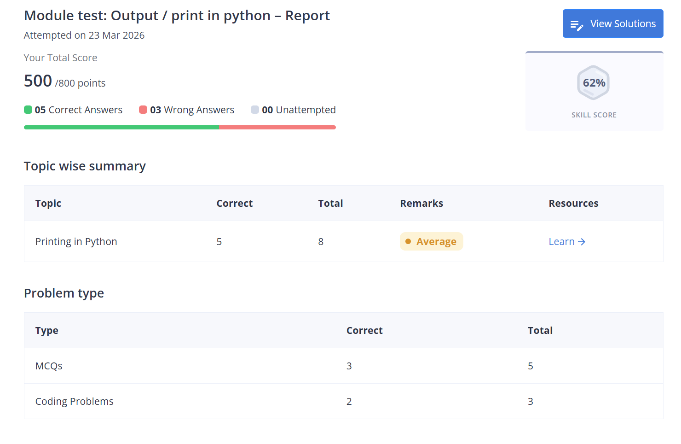
Part-A:-
Ex-Codehacker.
Part-B:-
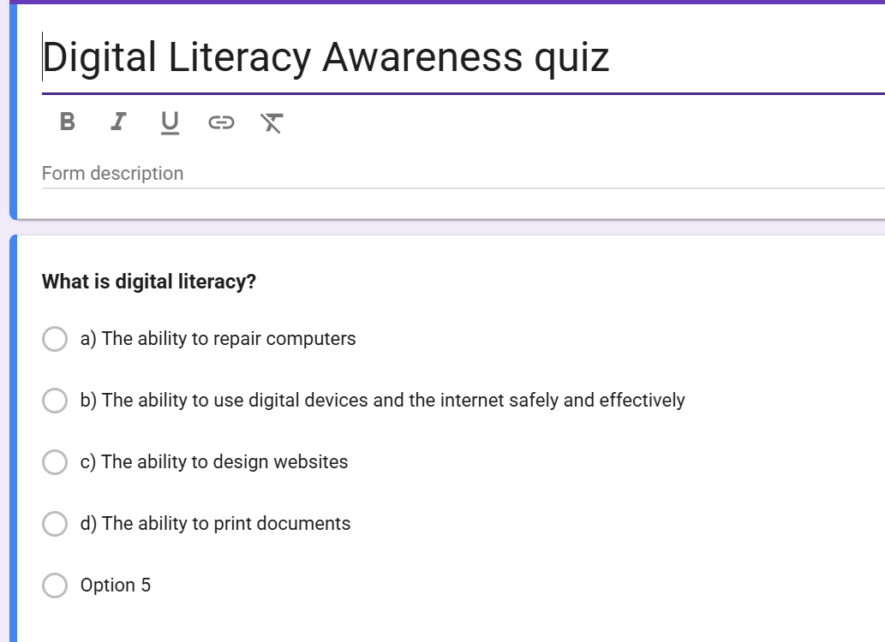

Report:-
I have used Google forms official website as a platform to test the knowledge of my batchmates to be as a part of my digital ambassador role.My using google , I built on how simple use of these apps can help as with the analysis of each and every thing in our data collection and separating on the basis of the data or the comparison provided with. It helps to classify data and the amount of people who did good in their responses.
Tools like google form helps us academically by providing a overview by testing our knowledge skills. It also helps with the comparison on how far or how close we are to the goal we are suppose to achieve.
Concluding , Google forms helps as learn alot

